ECA5801-IOE AND AI DRIVEN SYSTEMS
K.POOJA SREE
192512245
EXPERIMENT 5.A
SIMULATION
A.Simulation and Performance Evaluation of People–Process–Data–Things IoE Framework using Edge/Fog-to-Cloud Pipeline with MQTT, Node-RED.

CODE:
# ============================================================
# EXPERIMENT A
# P-P-D-T IoE Framework using Edge/Fog-to-Cloud
# MQTT and Node-RED Simulation
# ===========================================================
import numpy as np
import pandas as pd
import matplotlib.pyplot as plt
# -------------------------------
# 1. Simulation Parameters
# -------------------------------

np.random.seed(42)

layers = ["Edge", "Fog", "Cloud"]

# Number of IoT data packets
num_packets = 1000

# Packet size in KB
packet_size = 2

# Simulation time in seconds
simulation_time = 10

# -------------------------------
# 2. Parameters for Edge, Fog, Cloud
# -------------------------------

throughput_capacity = {
"Edge": 95,
"Fog": 70,
"Cloud": 50
}

base_latency = {
"Edge": 10,
"Fog": 25,
"Cloud": 60
}

packet_loss = {
"Edge": 0.02,
"Fog": 0.04,
"Cloud": 0.06
}

# -------------------------------
# 3. Simulation
# -------------------------------

results = []

for layer in layers:

# Packet delivery
delivered_packets = int(
num_packets * (1 - packet_loss[layer])
)

# Throughput in Mbps
total_data_bits = delivered_packets * packet_size * 8 * 1024

throughput = total_data_bits / simulation_time / 1e6

# Limit according to layer capacity
throughput = min(
throughput,
throughput_capacity[layer]
)

# Latency in milliseconds
latency = base_latency[layer] + np.random.uniform(2, 8)

results.append([
layer,
delivered_packets,
throughput,
latency
])

# -------------------------------
# 4. Create Result Table
# -------------------------------

df = pd.DataFrame(
results,
columns=[
"Layer",
"Packets Delivered",
"Throughput (Mbps)",
"Latency (ms)"
]
)

df["Throughput (Mbps)"] = df["Throughput (Mbps)"].round(2)
df["Latency (ms)"] = df["Latency (ms)"].round(2)

print("\n========== P-P-D-T IoE SIMULATION RESULTS ==========\n")
display(df)

# -------------------------------
# 5. Throughput Graph
# -------------------------------

plt.figure(figsize=(5, 3))

plt.bar(
df["Layer"],
df["Throughput (Mbps)"]
)

plt.title("Throughput: Edge vs Fog vs Cloud")
plt.xlabel("IoE Processing Layer")
plt.ylabel("Throughput (Mbps)")
plt.grid(axis="y", alpha=0.3)

plt.show()

# -------------------------------
# 6. Latency Graph
# -------------------------------

plt.figure(figsize=(5, 3))

plt.bar(
df["Layer"],
df["Latency (ms)"]
)

plt.title("Latency: Edge vs Fog vs Cloud")
plt.xlabel("IoE Processing Layer")
plt.ylabel("Latency (ms)")
plt.grid(axis="y", alpha=0.3)

plt.show()

# -------------------------------
# 7. 5G vs 6G Comparison
# -------------------------------

network = ["5G", "6G"]

network_throughput = [1000, 5000]
network_latency = [10, 1]

comparison = pd.DataFrame({
"Network": network,
"Throughput (Mbps)": network_throughput,
"Latency (ms)": network_latency
})

print("\n========== 5G vs 6G COMPARISON ==========\n")
display(comparison)

# -------------------------------
# 8. 5G vs 6G Graph
# -------------------------------

fig, ax = plt.subplots(1, 2, figsize=(8, 3))

ax[0].bar(
comparison["Network"],
comparison["Throughput (Mbps)"]
)

ax[0].set_title("5G vs 6G Throughput")
ax[0].set_ylabel("Mbps")

ax[1].bar(
comparison["Network"],
comparison["Latency (ms)"]
)

ax[1].set_title("5G vs 6G Latency")
ax[1].set_ylabel("ms")

plt.tight_layout()
plt.show()

# -------------------------------
# 9. Conclusion
# -------------------------------

print("\n========== CONCLUSION ==========")

best_throughput = df.loc[
df["Throughput (Mbps)"].idxmax(),
"Layer"
]

lowest_latency = df.loc[
df["Latency (ms)"].idxmin(),
"Layer"
]

print("• Edge provides the highest throughput in the simulated IoE pipeline.")
print("• Edge provides the lowest latency because processing occurs closer to the device.")
print("• Fog provides an intermediate processing layer between Edge and Cloud.")
print("• Cloud introduces higher latency because data travels farther.")
print("• 6G provides higher throughput and lower latency than 5G in the comparison model.")

OUTPUT:
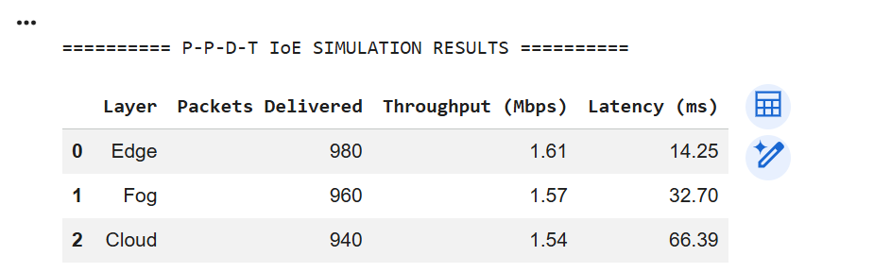
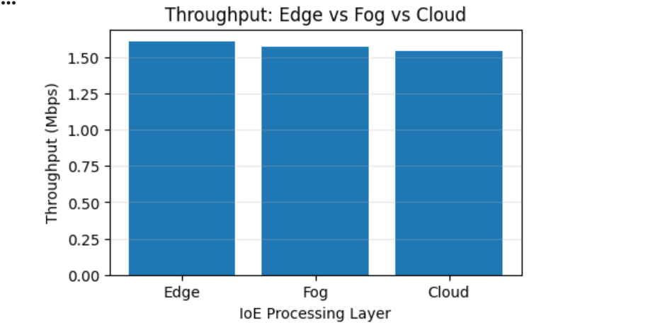
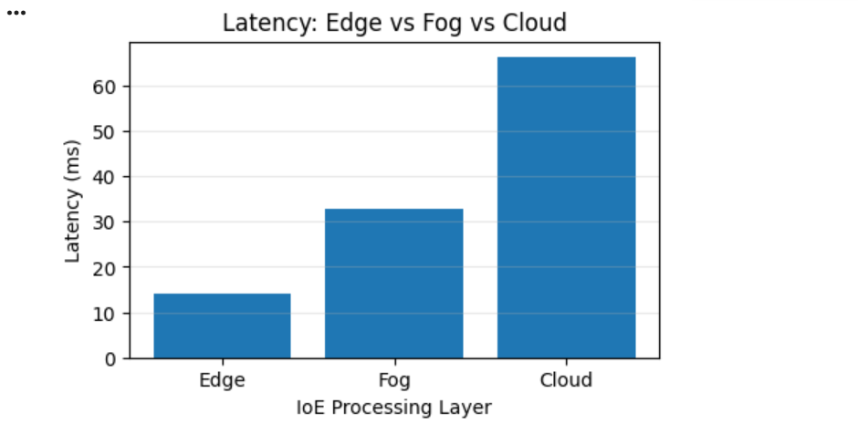
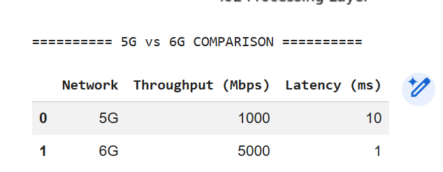
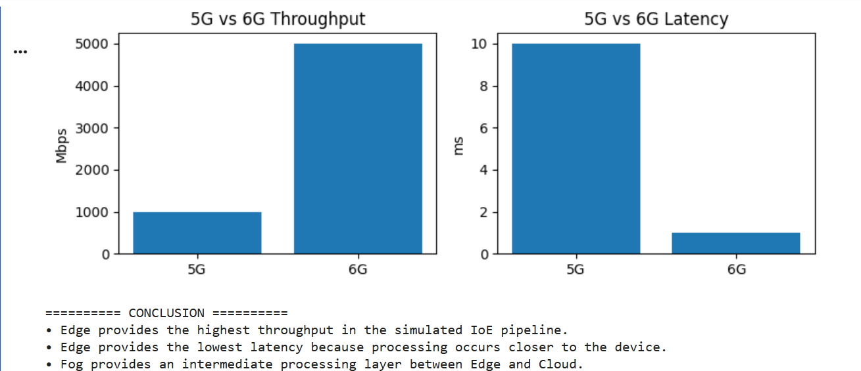

EXPERIMENT 5B
b.Benchmarking of 5G/6G Communication for IoE Applications based on Throughput, Latency, Reliability and Energy Efficiency
CODE:
# ============================================================
# EXPERIMENT B
# Benchmarking of 5G/6G Communication for IoE Applications
# ============================================================

import numpy as np
import pandas as pd
import matplotlib.pyplot as plt

# -------------------------------
# 1. Network Parameters
# -------------------------------

networks = ["5G", "6G"]

# Throughput in Mbps
throughput = [1000, 5000]

# Latency in milliseconds
latency = [10, 1]

# Reliability in percentage
reliability = [99.0, 99.99]

# Energy efficiency
# Higher value = better efficiency
energy_efficiency = [70, 90]

# -------------------------------
# 2. Create DataFrame
# -------------------------------

df = pd.DataFrame({
"Network": networks,
"Throughput (Mbps)": throughput,
"Latency (ms)": latency,
"Reliability (%)": reliability,
"Energy Efficiency (%)": energy_efficiency
})

print("\n========== 5G vs 6G IoE BENCHMARK ==========\n")

display(df)

# -------------------------------
# 3. Throughput
# -------------------------------

plt.figure(figsize=(5, 3))

plt.bar(
df["Network"],
df["Throughput (Mbps)"]
)

plt.title("5G vs 6G - Throughput")
plt.xlabel("Network")
plt.ylabel("Throughput (Mbps)")
plt.grid(axis="y", alpha=0.3)

plt.show()

# -------------------------------
# 4. Latency
# -------------------------------

plt.figure(figsize=(5, 3))

plt.bar(
df["Network"],
df["Latency (ms)"]
)

plt.title("5G vs 6G - Latency")
plt.xlabel("Network")
plt.ylabel("Latency (ms)")
plt.grid(axis="y", alpha=0.3)

plt.show()

# -------------------------------
# 5. Reliability
# -------------------------------

plt.figure(figsize=(5, 3))

plt.bar(
df["Network"],
df["Reliability (%)"]
)

plt.title("5G vs 6G - Reliability")
plt.xlabel("Network")
plt.ylabel("Reliability (%)")
plt.ylim(95, 100)

plt.grid(axis="y", alpha=0.3)

plt.show()

# -------------------------------
# 6. Energy Efficiency
# -------------------------------

plt.figure(figsize=(5, 3))

plt.bar(
df["Network"],
df["Energy Efficiency (%)"]
)

plt.title("5G vs 6G - Energy Efficiency")
plt.xlabel("Network")
plt.ylabel("Energy Efficiency (%)")

plt.grid(axis="y", alpha=0.3)

plt.show()

# -------------------------------
# 7. Combined Comparison
# -------------------------------

fig, ax = plt.subplots(2, 2, figsize=(8, 6))

ax[0, 0].bar(
df["Network"],
df["Throughput (Mbps)"]
)
ax[0, 0].set_title("Throughput")
ax[0, 0].set_ylabel("Mbps")

ax[0, 1].bar(
df["Network"],
df["Latency (ms)"]
)
ax[0, 1].set_title("Latency")
ax[0, 1].set_ylabel("ms")

ax[1, 0].bar(
df["Network"],
df["Reliability (%)"]
)
ax[1, 0].set_title("Reliability")
ax[1, 0].set_ylabel("%")

ax[1, 1].bar(
df["Network"],
df["Energy Efficiency (%)"]
)
ax[1, 1].set_title("Energy Efficiency")
ax[1, 1].set_ylabel("%")

plt.tight_layout()
plt.show()

# -------------------------------
# 8. Automatic Comparison
# -------------------------------

print("\n========== COMPARISON ==========\n")

if throughput[1] > throughput[0]:
print("✓ 6G has higher throughput than 5G.")

if latency[1] < latency[0]:
print("✓ 6G has lower latency than 5G.")

if reliability[1] > reliability[0]:
print("✓ 6G has higher reliability than 5G.")

if energy_efficiency[1] > energy_efficiency[0]:
print("✓ 6G has better energy efficiency than 5G.")

# -------------------------------
# 9. Conclusion
# -------------------------------

print("\n========== CONCLUSION ==========\n")

print("6G provides better simulated performance than 5G")
print("for IoE applications in terms of:")
print("• Higher throughput")
print("• Lower latency")
print("• Higher reliability")
print("• Better energy efficiency")
OUTPUT:
